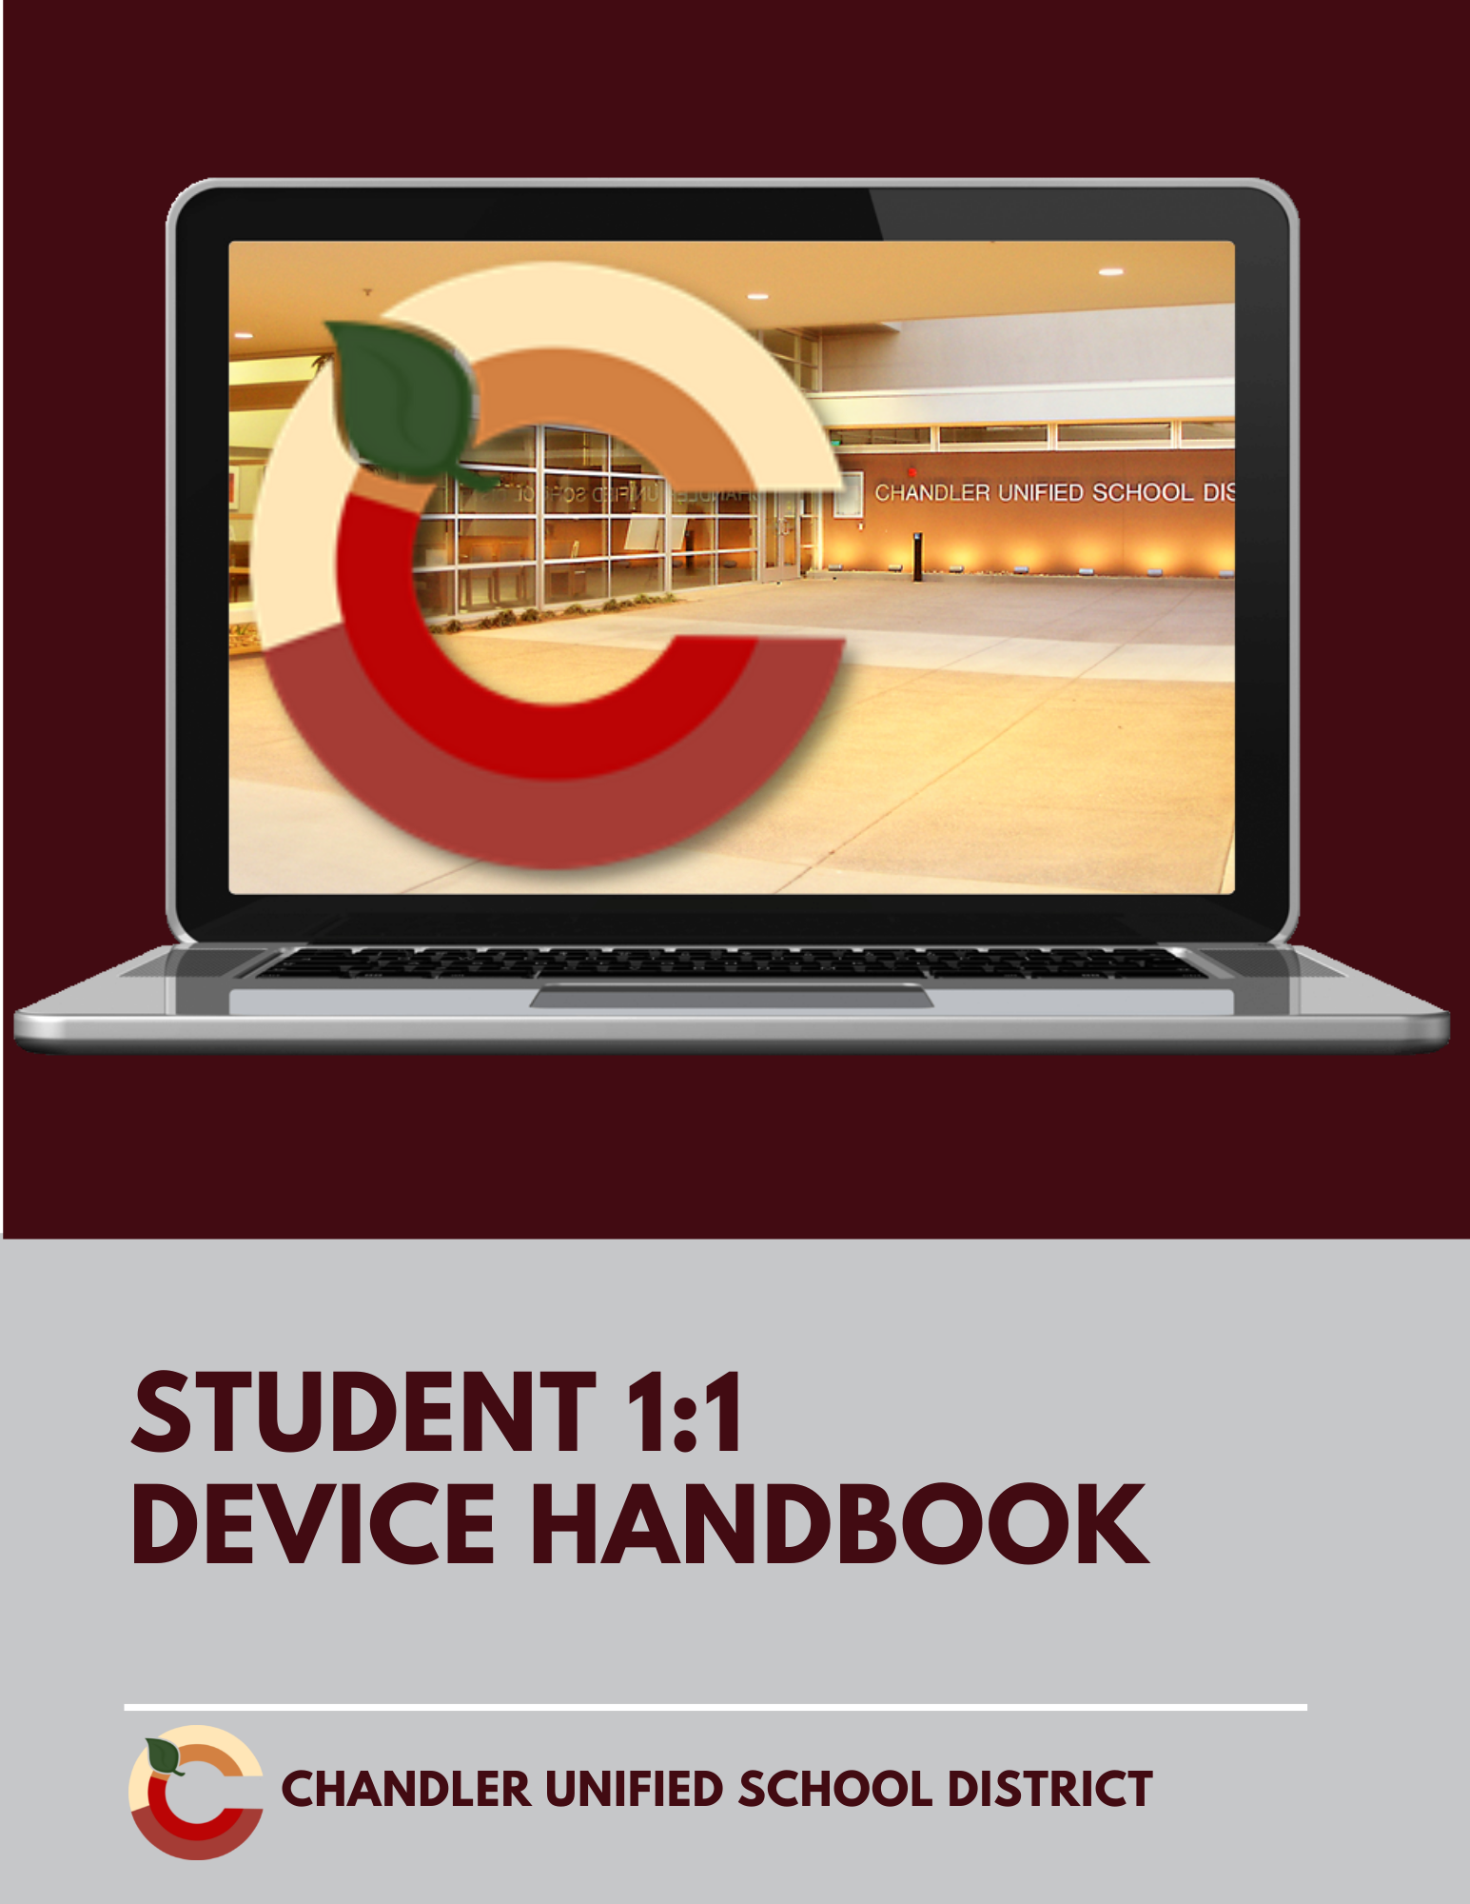

Table of Contents

Introduction | 3
Parent/Guardian Responsibilities | 3
Acceptable Use | 4
Receiving and Returning Your Device | 4-5
Using the Device Securely | 5
Caring For Your Device | 5-6
Device Protection Plan (DPP) | 6-7
Repair/Replace Procedures | 8
Link to 1:1 Student Guide Site

Introduction
CUSD students attending a 1:1 technology site will use district-issued devices to support their education. The individual use of digital devices is a way to empower students to maximize their full potential to prepare them for their educational and career future, becoming digitally responsible citizens. Teaching and learning through the integration of digital devices can not only increase student engagement and ownership of learning, but will also allow for effective transformation of curriculum that can take place anywhere and at any time.

Parent/Guardian Responsibilities
A strong partnership between school and home will help students be successful using 1:1 technology. Parent responsibilities are to:
- Review the information in this handbook.
- Determine whether to select the Device Protection Plan offered by the district or assume the financial responsibility for damage, loss or theft. Plan details are on Page __ of this handbook.
- Monitor student use away from school.
- Ensure the device is properly cared for outside of school.

Student Responsibility
Students must use their device in compliance with governing board policy, which outlines appropriate technology use.

The district retains control, custody and supervision of all district technology. The district reserves the right to monitor student usage of all district technology. Students have no right of privacy in their use of district technology, including email and stored files.

Digital Citizenship
Chandler Unified School District works to build a positive school culture with Common Sense Education K-12 Digital Citizenship curriculum to address the safe and responsible use of technology. The Common Sense K-12 Digital Citizenship Curriculum is designed to empower students to think critically, behave safely, and participate responsibly in our digital world.

Cyberbullying
The National Crime Prevention Council defines cyberbullying as “When the internet, cell phones, or other devices are used to send or post text or images intended to hurt or embarrass another person.” Cyberbullying will not be tolerated. See board policy IJNDC

Acceptable Use Policy
Students and parents must sign the Student Loan Device Agreement. to acknowledge they have read this policy, including its regulation, and understand that violation of this policy will result in a loss of privileges and further disciplinary action taken by the school’s administration. A copy of the signed agreement will be emailed to the parent. A paper copy of the loan agreement is available here: https://bit.ly/3o4rTYD

“Traditional” Classroom Issues | Equivalent Technology Related Issues
Coming to class unprepared | Failure to bring device to school or failure to bring a charged device to school
Passing notes, reading magazines, game, etc | Email, texting, social media, internet surfing, etc
Breaking into someone’s locker or classroom | Using an account belonging to another student or staff member
Bringing inappropriate material into school via a traditional media type | Accessing inappropriate material
Inappropriate language, harassment | Using profanity, obscenity, racist terms
Cheating, plagiarism, copying assignments | Sending/Forwarding assignments to another student for the purpose of cheating

Receiving Your Device
To receive a device, a student must be enrolled in a CUSD site with the 1:1 program and have signed the electronic CUSD Student Loan Device Agreement.
Please contact your site for specific information about device distribution. Students who have not signed the agreement during the device distribution can pick up their device at the Tech Center.
Devices will be checked out to the students through our asset management system with a specific loan period. Email notifications may be sent from the system to the primary email address in Infinite Campus as well as the student's email address.

Returning Your Device
The device must be returned to the school
- At the end of the school year
- Upon withdrawal or transfer to another district or school
- At the request of the school

The device must be returned in an undamaged condition with all parts and accessories included or fines may be assigned.

Fee and Fine Payments
Fees and Fines will be assessed via inTouch and made available to students and parents through Infinite Campus. Instructions for making payments through Infinite Campus can be found using this link.

Using the Device Securely
Students are required to enter their district-assigned user ID and password to operate the device. The device has security features and filtering intended to protect and prohibit your student from accessing inappropriate materials on the internet, unless the student has taken specific action to bypass these features. Security features and filtering are in effect for their device at school and at home or on other wifi enabled networks, including public libraries, restaurants, etc… as required by the Children’s Internet Protection Act (CIPA). If your student does not have access to wifi at home, contact their school for options.

Caring For Your Device
Proper use and care of your student device is essential. This includes caring for the power cord. Please follow these guidelines:

At all times
- Follow the Student Responsibilities
- Protect your device from damage due to food or liquids
- Protect your device from extreme heat or cold
- Do not place items on top of your device.

At school
- Do not leave your device unattended.
- Secure your device properly in your bag or backpack when not in use.
- Keep your power cord with you.

At home
- Charge your device every night. Students are expected to come to school with a fully charged device.
- Store your power cord with your device.
- Do not leave your device unattended where it could be accidentally damaged by food, liquids, pets or small children.

Traveling to and from school
- Do not leave your device in a vehicle or on the school bus.
- In public, keep your device out of view.
- Secure your device properly in your bag or backpack while traveling.

Device care
- Use a soft, dry microfiber or lint-free cloth to clean your device screen.
- Report any issues with your device promptly to a parent, teacher or school official.
- Do not remove the district barcode or school identification sticker from your device.
- Do not install, uninstall or modify any application, game or operating system component without school authorization.
- Do not deface the device exterior, including unauthorized stickers.

Device Protection Plan (DPP)
As part of the 1:1 technology initiative, a student fee of $25 will be added to inTouch to enroll in the Device Protection Plan (DPP). Enrollment in the plan will minimize the potential repair and/or replacement fees associated with the device. The Device Protection Plan does not begin until the fee is paid through inTouch in Infinite Campus. The fee must be paid by the due date in order to be enrolled in the plan. Click here for instructions to pay the fee in Infinite Campus.

Intentional damage to the device is not covered under the plan.

Enrollment in the DPP does not begin until the fee payment has been received. There will be no refunds given on DPP purchase if a student leaves CUSD or upon graduation. The fee is not prorated for any reason.

What is covered under the plan?
- Accidental damage, such as cracked screens, broken keyboard, etc.
- Battery replacement (if determined that the battery is malfunctioning)
- Replacement of stolen device with official police report. A police report must be filed within 48 hours. A copy of the report must be sent to the school office
- Hardware issues (video cable, broken ports, speakers)

A lost device and intentional damage to the device and/or AC adapters are NOT covered under the plan.

Repair/Replace Procedures
If a device becomes damaged, the parent or student will bring the device to the Tech Center. A loaner device will be checked out to the student until the device is repaired. The Technology Services department will repair the device or send it out for repairs..

If the device is lost, a fee will be assessed. If the device is stolen while at school, the incident must be reported by the student to their teacher, librarian or front office within 24 hours. If the device is stolen outside of school, the parent/guardian must file a police report within 48 hours. A copy of the report must be turned in to the schools front office.

Parents and students who choose NOT to purchase the Device Protection Plan are responsible for all repairs or replacement costs unless it is due to a manufacturer issue.

The following prices are estimates, as exact costs for each repair will be made upon further inspection of the damaged device. Should the student’s device become damaged, the student will be provided a loaner device, while their assigned device is being repaired. Once the assigned device is repaired, the loaner will be collected. All repairs must be made by a CUSD technician or authorized vendor.

Chromebooks | With  DPP | Without  DPP
Device Replacement (lost or damage beyond repair) | $150 | $400
Device Replacement (stolen - Police Report Required) | $0 | $400
AC Adapter Power Cord | $25 | $35
Battery | $0 | $100
Touchpad | $0 | $30
Display Panel (Screen) | $20 | $100
Display Bezel (Front Cover) | $0 | $25
Display Back Cover | $0 | $40
Keyboard | $25 | $75
Webcam | $0 | $30
System Board | $20 | $200
Windows Devices | With  DPP | Without  DPP
Device Replacement (lost or damage beyond repair) | $200 | $500
Device Replacement (stolen - Police Report Required) | $0 | $500
AC Adapter Power Cord | $25 | $35
Battery | $0 | $0
Touchpad | $0 | $40
Display Panel (Screen) | $20 | $125
Display Bezel (Front Cover) | $0 | $30
Display Back Cover | $0 | $40
Keyboard | $25 | $75
Webcam | $0 | $30
System Board | $20 | $200

